**Inglés 1 - Diagnóstico**

**The Computer**

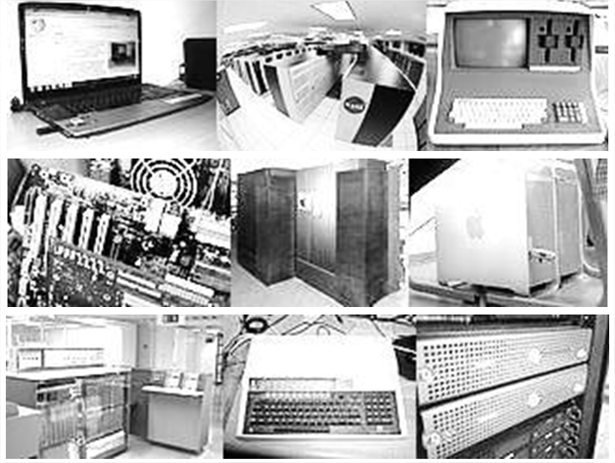

A computer is a general purpose device that can be programmed to carry out a set of arithmetic or logical operations automatically. Since a sequence of operations can be readily changed, the computer can solve more than one kind of problem.

Conventionally, a computer consists of at least one processing element, typically a central processing unit (CPU), and some form of memory. The processing element carries out arithmetic and logic operations, and a sequencing and control unit can change the order of operations in response to stored information. Peripheral devices allow information to be retrieved from an external source, and the result of operations saved and retrieved.

In World War II, mechanical analog computers were used for specialized military applications. During this time, the first electronic digital computers were developed. Originally, they were the size of a large room, consuming as much power as several hundred modern personal computers (PCs).

Modern computers based on integrated circuits are millions to billions of times more capable than the early machines and occupy a fraction of the space. Simple computers are small enough to fit into mobile devices, and mobile computers can be powered by small batteries. Personal computers in their various forms are icons of the Information Age and are what most people think of as “computers.” However, the embedded computers found in many devices from MP3 players to fighter aircraft and from toys to industrial robots are the most numerous.

*Fuente:* [*http://en.wikipedia.org/wiki/Computer*](http://en.wikipedia.org/wiki/Computer)

**De acuerdo a lo visto en el texto anterior, resuelva los siguientes ejercicios:**

1. **¿Qué tipo de paratextos emplea el texto?**

Como paratexto tiene una imagen de diferentes computadoras

I can see images about computers as paratext (Me costo un poco pensarlo)

1. **Lea el texto e indique:**
2. **¿a quiénes está dirigido?**

(No estoy seguro) Creo que a un publico en general

I am not sure but i think people general

1. **¿a qué campo disciplinar, área o ciencia se inscribe el tema?** ……………………………………………………………………….……………………………………………………………………………………....……………….
2. **Busque un sinónimo de: *machine***

Aparato, y en ingles no me sale ninguna

1. **Busque un hipónimo de: *device*** ……………………………………………………………………………………………
2. **Busque ejemplos de repetición léxica.**

……………………………………………………………………………………………

1. **Traslade el primer párrafo al español.**

Una computadora es un aparato general con el propósito de poder programar y lograr *(no se bien carry out acá)* aritmética u operaciones lógicas automáticamente. Desde una secuencia de operaciones se puede cambiar, la computadora puede resolver mas de un problema a la vez